OO-Calc guide to join data rows

Export pink cards from PCRM – lets name this file pinkcards_mis.xls
Export leads from PCRM – lets name this file leads_mis.xls
Start OO Base and create a new database and follow the steps given below.
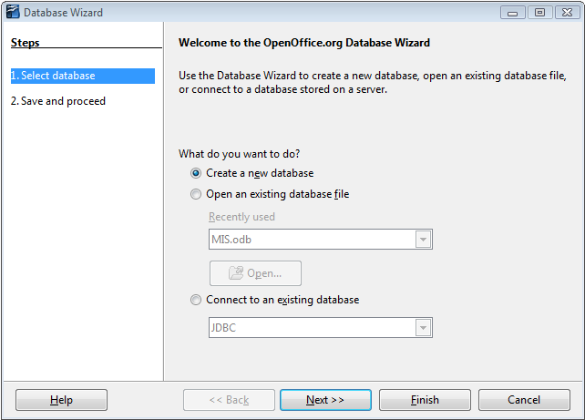

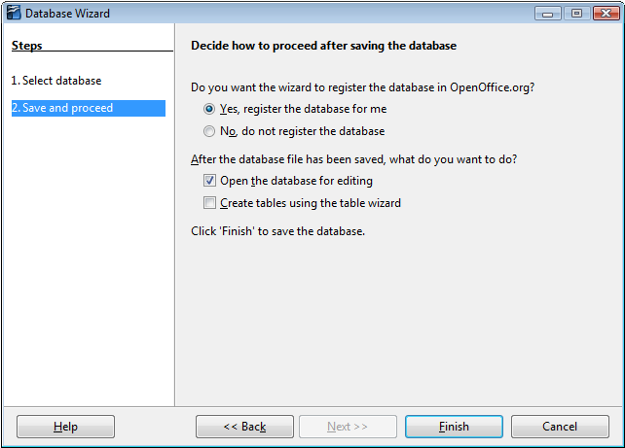

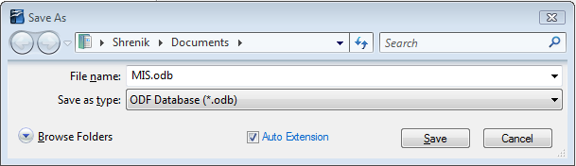

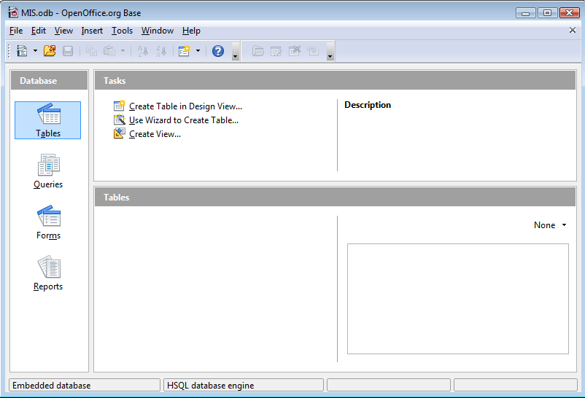
Once you reach this screen, copy paste the data from the each of the exported spread-sheets onto the Tables area.

It shall bring you to this screen wherein you may define the parameters as shown below.
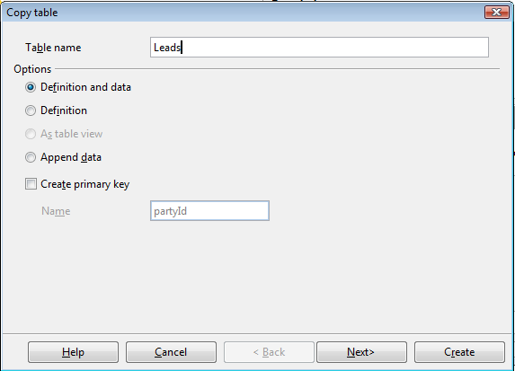
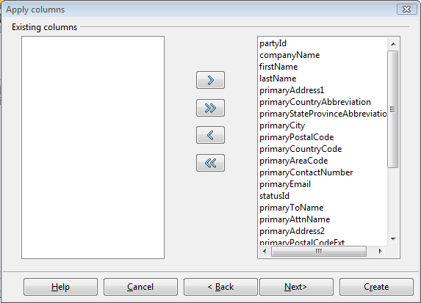
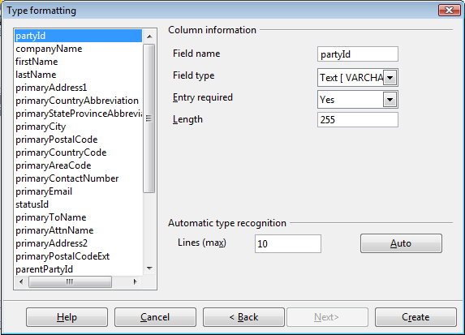
Clicking on create brings up this pop-up for which we may click Yes.
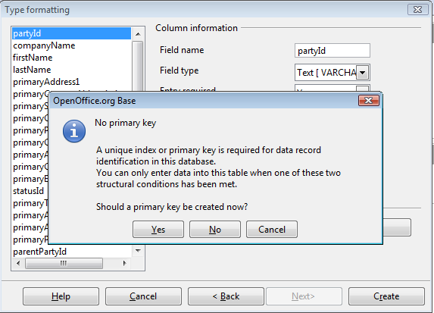
Herein we have the Leads table ready.
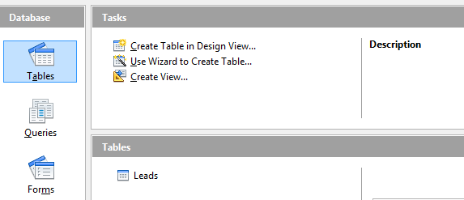

Similarly repeat the steps for the Pink Card data from the exported spreadsheet.
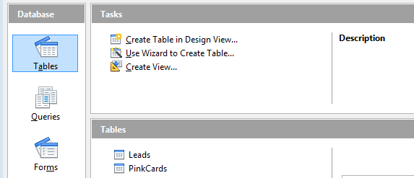

Next click on the Queries widget in the left pane.
Now select and Add the requisite tables from the Add Table or Query dialog.
Then drag and link the partyId from the Leads table to the leadPartyId from the Pink Cards table.

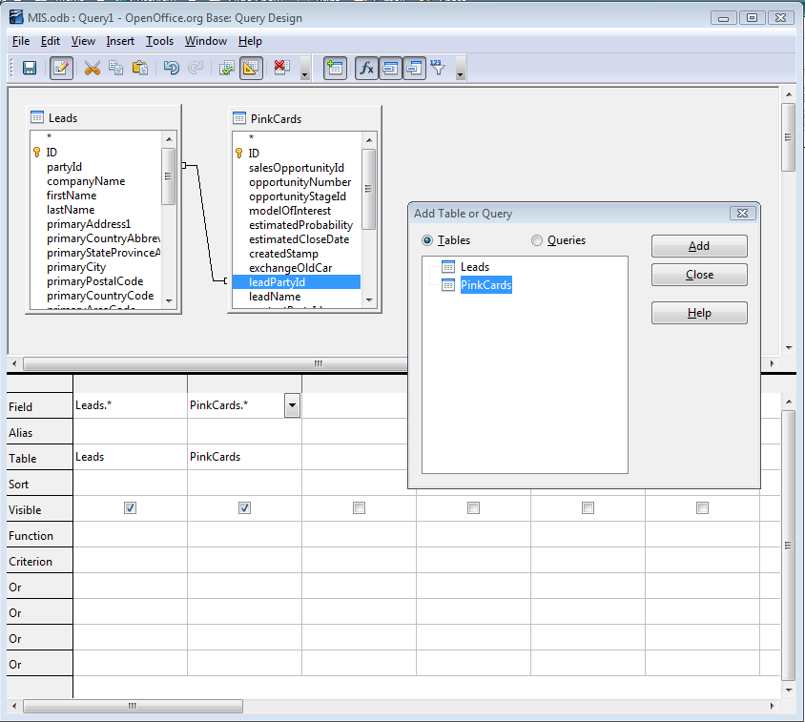
Thereafter click on the Run Query button present in the top toolbar.

This is the resultant joined data which must be saved as a query.
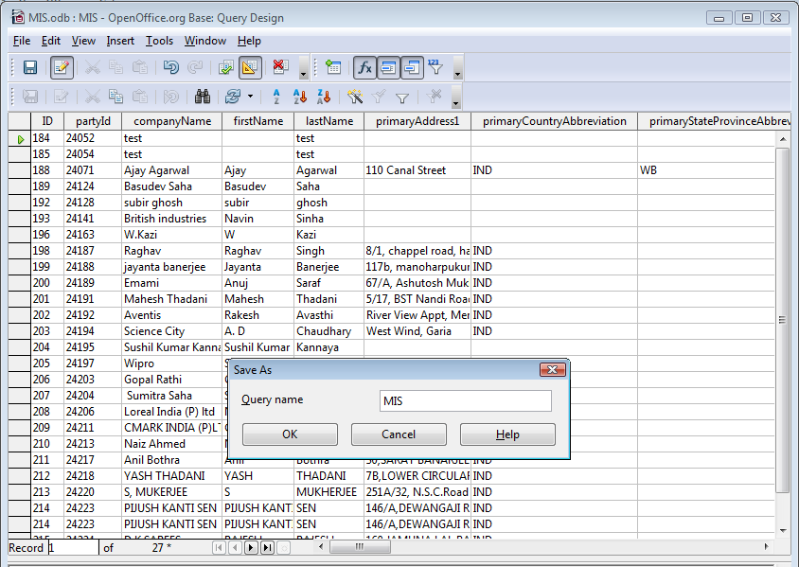
Once saved you may close the Query window.

Next right-click and copy the query. This shall copy the entire data set present in the query to the clip-board.
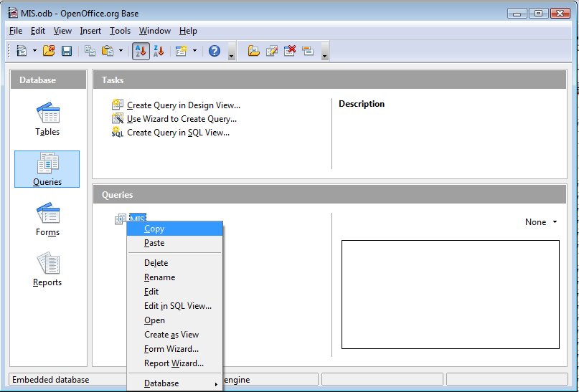

Thereafter open a new Calc spreadsheet and paste the data.
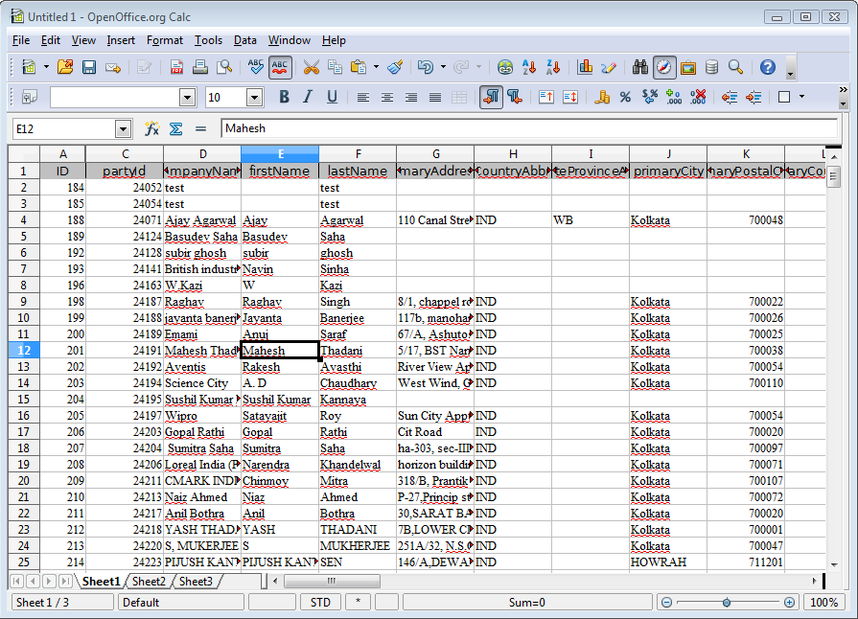
The entire joined data is pasted in the spread-sheet which may be used for further MIS reporting.

